Project Design Phase
Solution Architecture

Date | 25 September 2026
Team ID
Project Name | FreelanceHub – Freelance Marketplace Platform
Maximum Marks | 4 Marks

Solution Architecture:
Solution architecture is a complex process — with many sub-processes — that bridges the gap between business problems and technology solutions. Its goals are to:
- Find the best tech solution to solve existing business problems.
- Describe the structure, characteristics, behavior, and other aspects of the software to project stakeholders.
- Define features, development phases, and solution requirements.
- Provide specifications according to which the solution is defined, managed, and delivered.

FreelanceHub – Solution Architecture Diagram:

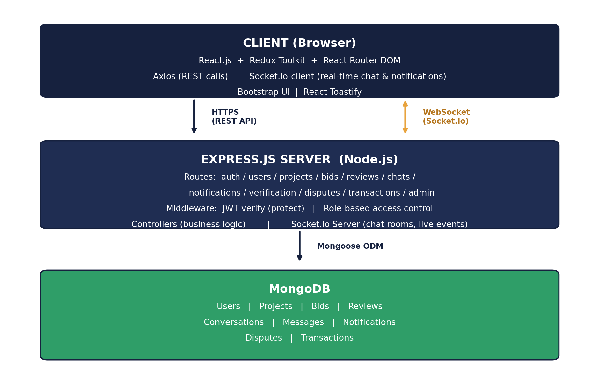
Figure 1: FreelanceHub client–server architecture and real-time data flow

